**Giorgio Armani Emporio Armani Stronger With You Intensely**

38 240Ft

Top notes are Pink Pepper, Juniper and Violet; middle notes are Toffee, Cinnamon, Lavender and Sage; base notes are Vanilla, Tonka, Bean, Amber and Suede.

Hugo Boss **BOSS Bottled**

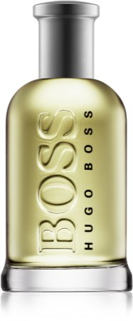 20 630Ft

Top notes are Apple, Plum, Lemon, Bergamot, Oakmoss and Geranium; middle notes are Cinnamon, Mahogany and Carnation; base notes are Vanilla, Sandalwood, Cedar, Vetiver and Olive Tree.

Chanel **Bleu de Chanel** Eau de Parfum

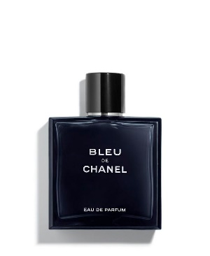**69 570Ft**

Top notes are Grapefruit, Lemon, Mint, Pink Pepper, Bergamot, Aldehydes and Coriander; middle notes are Ginger, Nutmeg, Jasmine and Melon; base notes are Incense, Amber, Cedar, Sandalwood, Patchouli, Amberwood and Labdanum

CK One Calvin Klein

# CK One Calvin Klein for women and men 11 290Ft

Top notes are Lemon, Green Notes, Bergamot, Mandarin Orange, Pineapple, Cardamom and Papaya; middle notes are Lily-of-the-Valley, Jasmine, Violet, Nutmeg, Rose, Orris Root and Freesia; base notes are Green Accord, Musk, Cedar, Sandalwood, Oakmoss, Green Tea and Amber

# The One for Men Eau de Parfum Dolce&Gabbana

# The One for Men Eau de Parfum Dolce&Gabbana for men 42 420Ft

Top notes are Grapefruit, Coriander and Basil; middle notes are Cardamom, Ginger and Orange Blossom; base notes are Amber, Tobacco and Cedar

# Sauvage Dior

# Sauvage Dior for men 41 180Ft

Top notes are Calabrian bergamot and Pepper; middle notes are Sichuan Pepper, Lavender, Pink Pepper, Vetiver, Patchouli, Geranium and elemi; base notes are Ambroxan, Cedar and Labdanum

# Gucci Guilty Pour Homme Parfum Gucci

# Gucci Guilty Pour Homme Parfum Gucci for men 35 350Ft

Top notes are Juniper, Lavender and Lemon; middle notes are Orange Blossom, Nutmeg and Spanish Labdanum; base notes are Dry Wood, Patchouli and Musk

# Oud Wood Tom Ford

# Oud Wood Tom Ford for women and men Oud Wood Tom Ford

# Oud Wood by Tom Ford is a Amber Woody fragrance for women and men. Oud Wood was launched in 2007. The nose behind this fragrance is Richard Herpin.

**Eros Versace**

# Eros Versace for men 34 030Ft

Top notes are Mint, Green Apple and Lemon; middle notes are Tonka Bean, Ambroxan and Geranium; base notes are Madagascar Vanilla, Virginian Cedar, Atlas Cedar, Vetiver and Oakmoss.

# Y Eau de Parfum Yves Saint Laurent

# Y Eau de Parfum Yves Saint Laurent for men 46 200Ft

Top notes are Apple, Ginger and Bergamot; middle notes are Sage, Juniper Berries and Geranium; base notes are Amberwood, Tonka Bean, Cedar, Vetiver and Olibanum.